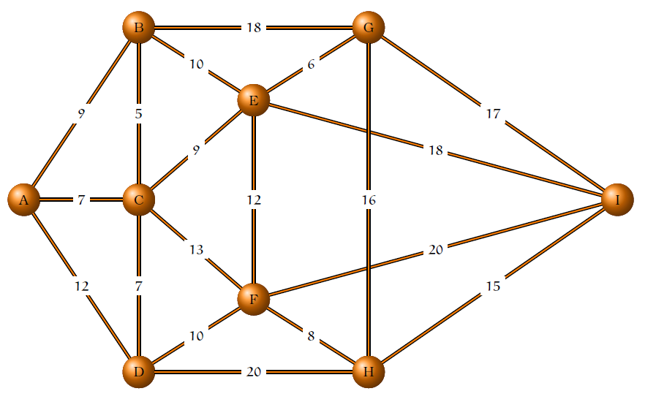

RAMOS

(E,F)

(C,F)

(H,I)

(G,H)

(G,I)

(B,G)

(E,I)

(D,H)

(F,I)

(B,C)

(E,G)

(A,C)

(C,D)

(F,H)

(C,E)

(A,B)

(B,E)

(D,F)

(A,D)

|  |  |  |  |  |  |  |  |  |  |  |  |  |  |  |  |  |
| --- | --- | --- | --- | --- | --- | --- | --- | --- | --- | --- | --- | --- | --- | --- | --- | --- |
| It | (vi,vj) | Si | Sj | T | S1 | S2 | S3 | S4 | S5 | S6 | S7 | S8 | S9 | S10 | S11 | Nr |
|  |  |  |  |  | A | B | C | D | E | F | G | H | I |  |  |  |
| 1 | (B, C) | 2 | 3 | (B, C) | A | B, C | D | E | F | G | H | I |  |  |  | 1 |
| 2 | (E, G) | 4 | 6 | (E, G) | A | B, C | D | E,G | F | H | I |  |  |  |  | 2 |
| 3 | (A, C) | 1 | 2 | (A, C) | A, B, C | D | E, G | F | H | I |  |  |  |  |  | 3 |
| 4 | (C, D) | 1 | 2 | (C, D) | A, B, C, D | E, G | F | H | I |  |  |  |  |  |  | 4 |
| 5 | (F, H) | 3 | 4 | (F, H) | A, B, C, D | E, G | F, H | I |  |  |  |  |  |  |  | 5 |
| 6 | (C, E) | 2 | 1 | (C, E) | A, B, C, D, E, G | F, H | I |  |  |  |  |  |  |  |  | 6 |
| 7 | (A, B) | 1 | 1 |  |  |  |  |  |  |  |  |  |  |  |  |  |
| 8 | (B, E) | 1 | 1 |  |  |  |  |  |  |  |  |  |  |  |  |  |
| 9 | (D, F) | 1 | 2 | (D, F) | A, E, G, B, C, D, F, H | I |  |  |  |  |  |  |  |  |  | 7 |
| 10 | (A,D) | 1 | 1 |  |  |  |  |  |  |  |  |  |  |  |  |  |
| 11 | (E, F) | 1 | 1 |  |  |  |  |  |  |  |  |  |  |  |  |  |
| 12 | (C, F) | 1 | 1 |  |  |  |  |  |  |  |  |  |  |  |  |  |
| 13 | (H,I) | 1 | 2 | (H, I) | A, E, G, B, C, D, F, H, I |  |  |  |  |  |  |  |  |  |  | 8 |

A árvore é T={(B, C), (E, G), (A, C), (C, D), (F, H), (C, E), (D, F), (H, I)} e o custo é 5+6+7+7+8+9+10+15=67